eLearning Recording

**Recording of eLearning completions**

Due to the migration to NHS net, some staff that complete their eLearning under their old (@westlondon.nhs.uk) may experience delays in training being recorded.

To avoid this – please update your eLearning account as follows:-

1. Login to your eLearning account.
2. Once logged in go to settings

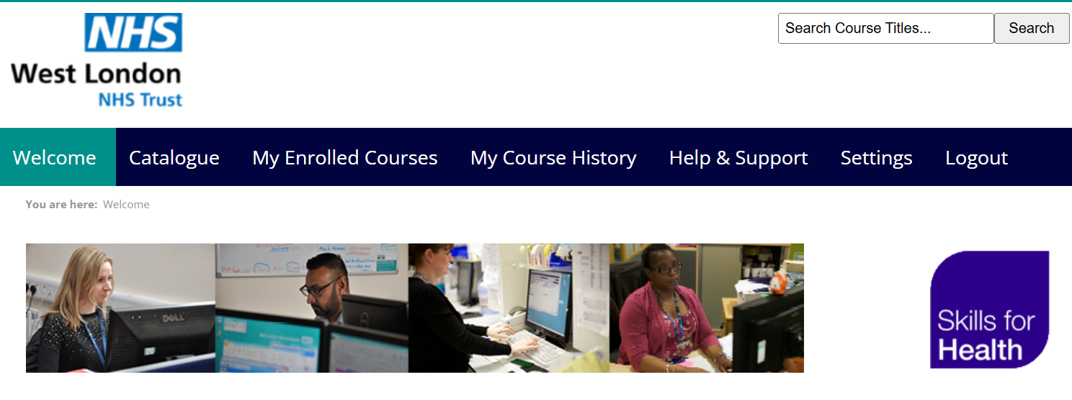

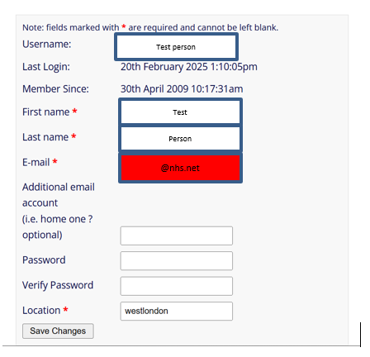

Update your new email @nhs.net email address and press

**Save Changes**